Our 3.5 VOC Compliant high-solids, single stage polyurethane is the ultimate choice for durability and excellent chemical resistance. With a deep finish, System 35™ provides excellent flow, leveling and flexibility, good color holdout, and is both impact and UV resistant – it even stands up to Skydrol.
System 35™ Polyurethane Single Stage Color

Product Cross Reference Information
Product comparisons are based on a similar product replacement. Performance and mix ratios may vary.
DuPont | PPG | SW | BASF
Imron® 5000™ 3.5 | Delta® DGHS 3.5 | Sunfire 3.5 | Diamont 3.5

DIRECTIONS FOR USE
Application recommendations are for an ambient shop temperature
of 75°F. Temperature and humidity will affect dry times.

MIX BY VOLUME (3:1)
Combine components by volume, mix thoroughly, and strain before spraying.
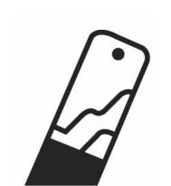
See Product Information Sheet #1017 for full usage details.

3 Parts System 35™ Color
1 Part PO35A™ Activator (normal or slow)
Optional ½ part reduction with TH028™ or TH035™ Low VOC Reducer

POT LIFE
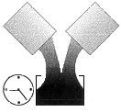
1 –2 hours at 75°F
Note: We suggest mixing only enough product for a single coat.

ADDITIVES
Accelerator: If needed, use 1 – 2 ounces of PE35ACC™ Accelerator per ready-to-spray gallon (or ¼ - ½ ounce per ready-to-spray quart). Note: the use of PE35ACC™ will extend pot life and increase cure rate by approximately 4-hours.

Fish Eye Eliminator: If needed, add 1-2 ounces of CR22FEE™ per ready-to-spray gallon (or ¼ - ½ ounce per ready-to-spray quart). Note: Use only Montana CR22FEE™ Fisheye Eliminator. Other brands may be incompatible.

GUN SETUP
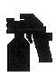
Fluid Tip Air Pressure
HVLP Gravity: 1.3 – 1.5mm 6 – 10 PSI at the cap
HVLP Siphon: 1.3 – 1.6mm 6 – 10 PSI at the cap
Conventional Gravity: 1.3 – 1.5mm 45 – 55 PSI at the gun
Conventional Siphon: 1.3 – 1.6mm 45 – 55 PSI at the gun

APPLICATION (As an overall or full-panel repair)
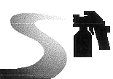
- Allow appropriate dry times of primers and sealers.
- Confirm color match is appropriate by testing color prior to application.
- Strain paint prior to application.
- Apply one medium wet coat and allow 20-minutes flash.
- Apply a 2nd full wet coat.
- If a 3rd coat is needed, for color hiding, allow 20-minutes flash between 2nd and 3rd coats, and apply a light coat. For best results, do not apply more than 3 coats.
- If metallics are being applied, apply one fog coat immediately after last coat, holding the spray gun back an additional 2 – 3”. Raising the air pressure a few pounds will help even out metallics.
- See Product Information Sheet #1017 for full usage details.

COMPOUNDING

- Air Dry: 24 – 72 hours at 75°F.
- See Product Information Sheet #1017 for full usage details.

PHYSICAL DATA

Dust Free: 60-90 minutes MSDS #20 (No Lead), #21 (Leaded)
Dry to Handle: Overnight Activator MSDS #6
VOC: 3.5 lbs/gal (maximum) Reducer MSDS #1
P.I.S. #1017

Read and follow all technical product information, labels, and MSDS prior to application. Keep product out of reach of children and animals. Always wear proper safety equipment (respirator, gloves, eye, and clothing protection) when using this product.
Rev. 6/16/05
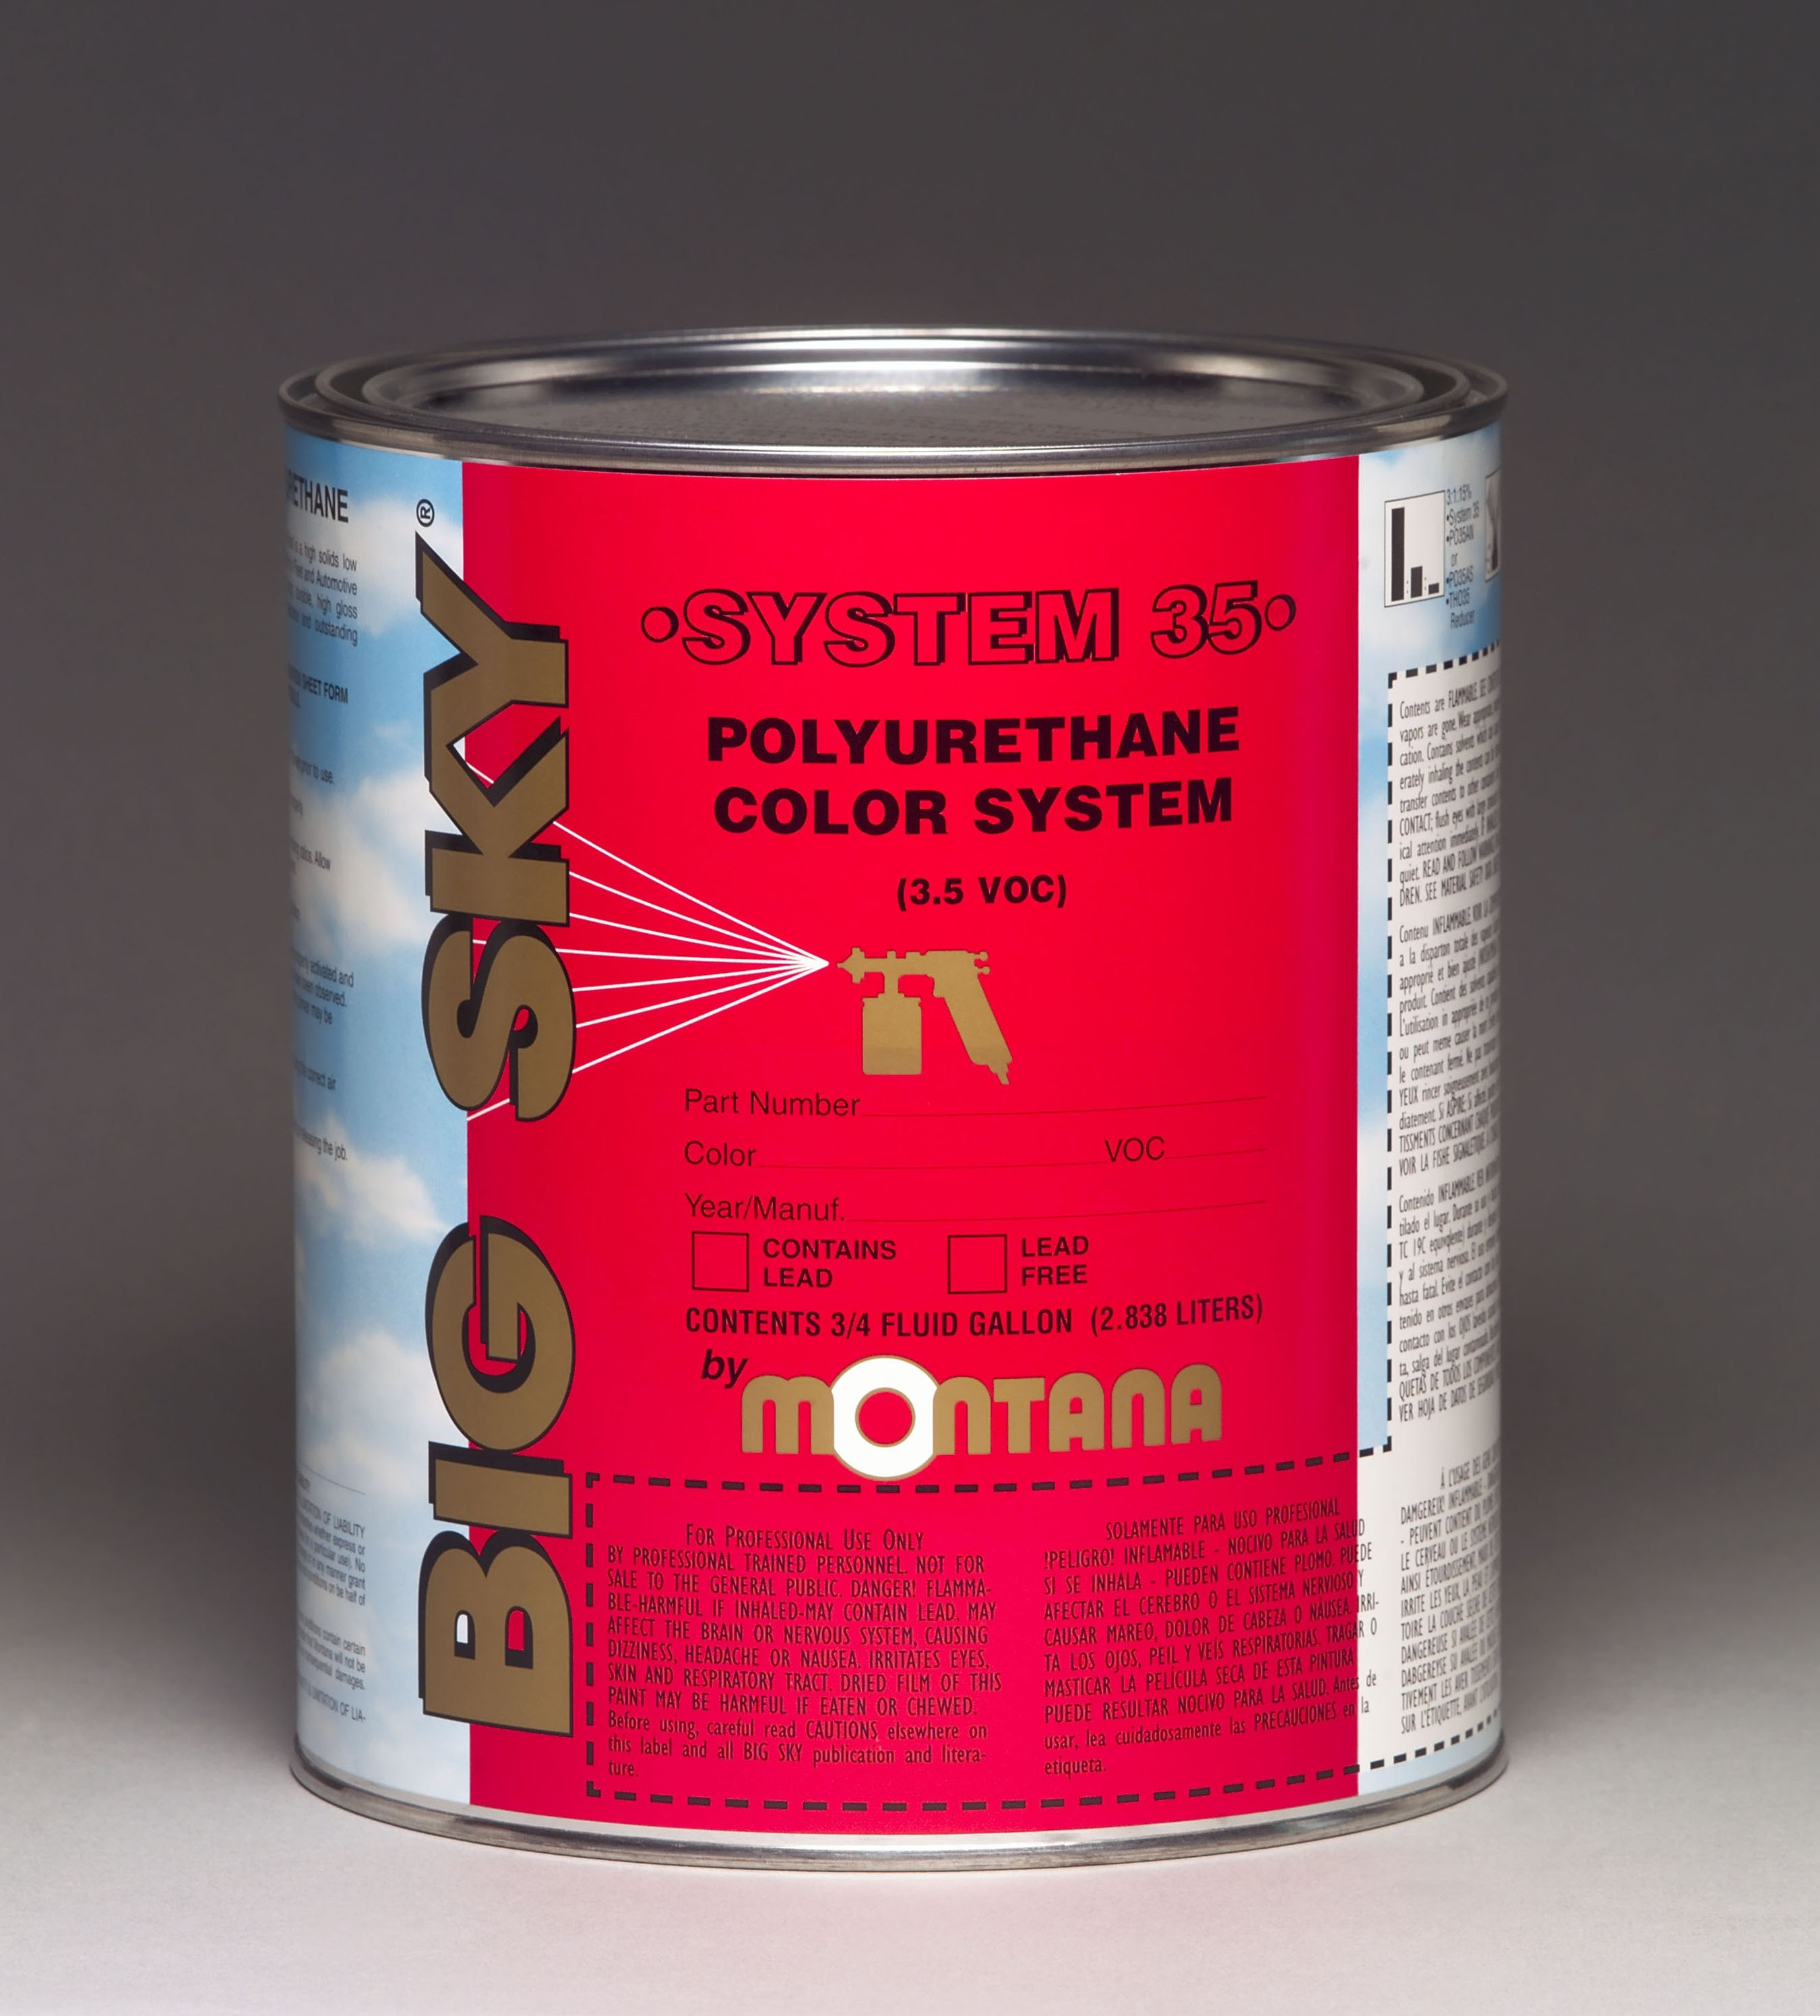


System 35™ Sell Sheet
Form #9016
DESCRIPTION
ADVANTAGES
BIG SKY
BIG SKY
®
Phone: (800) 328-4892 ● Fax: (330) 669-3965
9287 Smucker Road ● Orrville, OH ● 44667
Website: www.chemspec.co.za
www.montanabigsky.com
Our 3.5 VOC Compliant high-solids, single stage polyurethane is the ultimate choice for durability and excellent chemical resistance. With a deep finish, System 35™ provides excellent flow, leveling and flexibility, good color holdout, and is both impact and UV resistant – it even stands up to Skydrol.
High Solids. VOC Compliant. UV Resistant.
- Low 3.5 VOC Meets Strictest Regulations
- High Solids
- Excellent Chemical Resistance
- Provides a Deep Finish
SYSTEM 35™
3.5 VOC POLYURETHANE COLOR SYSTEM

